

WEEK 10:
Pictorial Puzzle
(1-9)
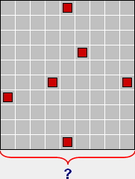
Place the digits (1 to 9) into the diagram's some of the cells which have not include the red square.
You have to use all digits (1 to 9) once.
A row or column can include no digit. There cannot be only one digit at a row or column.
So, there must be the digits more than one digit at a row or column. (Or no digit)
Try to find how will you place the digits by analyzing two solved example given below.
As answer, enter the number shown with the question mark.
Example.1 (1-7) Example.2 (1-8)
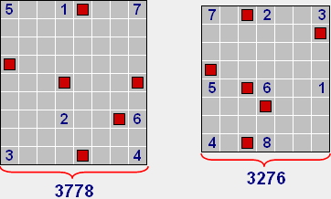
(115+411+817+472+876+193+894) | 117+412+713+155+456+751+184+488)

Optimization Puzzle
Place the blocks of 1x3 size, horizontally and vertically, into the diagram above.
Try to create as much as a long path whose tickness is 1 cell, among the blocks.
THE RULES:
1) You can place any number of blocks, however, the horizontal and vertical number of blocks have to be equal!
2) The edges of the blocks consist of the 8 units. At least, one of these 8 units have to touch to the path you created.
3) The path you created cannot intersect with itself and it can touch itself only from its corners.
Paint the cells which are outside the path, with the black colour.
INVALID  (RULE 1) | INVALID  (RULE 2) | INVALID  (RULE 3)
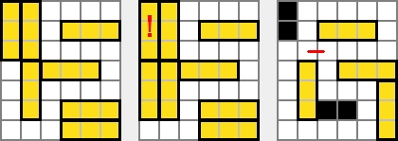
SCORE CALCULATION:
Firstly, type a numerical value into the each cells of the path you created.
This numerical value must be the total number of the neighbour block cells of that cell, in that direction.
If there is no neighbour block at four edges of a cell, type "0" into that cell.
Then, sum all the numerical value on your path.
Multiply this total value with the total number of the blocks you placed.
To find your actual score, divide this resulting number by total number of the black cells (if exist).
If you can create a closed path, multiply your score by 3.
Analyze the score calculations of the sample solutions, carefully!

SAMPLE SOLUTIONS AND SCORE CALCULATIONS:
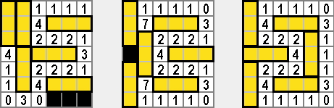
38 x 6 / 3 = 76 | 46 x 6 / 1 = 276 | 41 x 6 x 3 = 738

