

Puzzle 5:
INFURIATING NONOGRAM
 | Find out the figure we hide, by scribbling some cells at the platform.
 |  | Example puzzle: |  |  |  |  |  |  |  |  |  |  |  |  |  |  |  | Example solution:
 |  |  | 3 | 2 | 3 | 3 | 3 | 3 | 2 | 3 | 1 |  |  |  |  |  |  |  | 3 | 2 | 3 | 3 | 3 | 3 | 2 | 3 | 1
 |  |  | 1 | 1 | 2 | 1 | 1 | 2 | 1 | 1 | 1 |  |  |  |  |  |  |  | 1 | 1 | 2 | 1 | 1 | 2 | 1 | 1 | 1
 | 7 | 2 |  |  |  |  |  |  |  |  |  | 2 |  | 0 |  |  | 7 | 2 |  |  |  |  |  |  |  |  |  | 2 | 0
 | 4 | 2 |  |  | * |  |  |  |  |  |  | 4 |  | 2 |  |  | 4 | 2 |  |  | * |  |  |  |  |  |  | 4 | 2
 | 2 | 2 |  |  |  |  |  | * |  |  |  | 6 |  | 2 |  |  | 2 | 2 |  |  |  |  |  | * |  |  |  | 6 | 2
 | 2 | 2 |  | * |  |  |  |  |  |  |  | 3 |  | 2 |  |  | 2 | 2 |  | * |  |  |  |  |  |  |  | 3 | 2
 | 2 | 2 |  |  |  |  |  |  |  |  |  | 3 |  | 3 |  |  | 2 | 2 |  |  |  |  |  |  |  |  |  | 3 | 3
 | 0 | 0 | * |  |  | * |  |  | * |  |  | 9 |  | 3 |  |  | 0 | 0 | * |  |  | * |  |  | * |  |  | 9 | 3
 | 2 | 1 |  |  |  |  |  |  |  |  |  | 4 |  | 2 |  |  | 2 | 1 |  |  |  |  |  |  |  |  |  | 4 | 2
 | 2 | 1 |  | * |  |  |  |  |  |  |  | 4 |  | 2 |  |  | 2 | 1 |  | * |  |  |  |  |  |  |  | 4 | 2
 | 2 | 1 |  |  |  |  |  |  | * |  |  | 4 |  | 2 |  |  | 2 | 1 |  |  |  |  |  |  | * |  |  | 4 | 2
 |  |  | 6 | 7 | 4 | 6 | 6 | 4 | 7 | 6 | 8 |  |  |  |  |  |  |  | 6 | 7 | 4 | 6 | 6 | 4 | 7 | 6 | 8
 |  |  | 3 | 3 | 1 | 2 | 2 | 1 | 2 | 2 | 2 |  |  |  |  |  |  |  | 3 | 3 | 1 | 2 | 2 | 1 | 2 | 2 | 2

 |  |  | *
 |  |  |  |  |  | *
 |  | *
 | * |  |  | * |  |  | *
 |  | *
 |  |  |  |  |  |  | *

The cells with the black point show one of the 4 corner cells of the square clusters to be scribbled.
Namely, each the cell with black point is belong to a different square cluster.
These square clusters can be at least 2x2 sizes. (Or more, etc 3x3, ...)
These square clusters can be adjacent to each other, but never override each other.
The black numbers (outermost) show how many cluster pieces at the row or column related are.
But, for you to find out and scribble these square clusters, is not enough to be formed the hidden figure.
Additionally, there are the other cells you have to scribble. But non of these cells cannot form a square cluster.
To find these, you will make use of the red and blue numbers.
The red numbers show the number of the cells of the longest cell group(s) which is/are scribbled at that row or column.

The huge ones of the blue numbers (at the top and at the left) show the total number of the white (empty) cells at that row or column.
These white cells are the cells you have to leave empty. (not scribbled)
The tiny ones of the blue numbers show how many group(s) is/are formed with these empty (white) cells at that row or column.
Solve the puzzle below, by analyzing the example puzzle and the solution above.
Your answer must be formed by "0" and "1". When you determining these numbers, you will deal with the cells which marked with the red line.
Use "0" for the empty cells, use "1" for the cells scribbled .
As answer, enter the 15 numbers at the direction shown, from top to bottom, one after another, without any space.
The answer of the example solution must be 001111111.

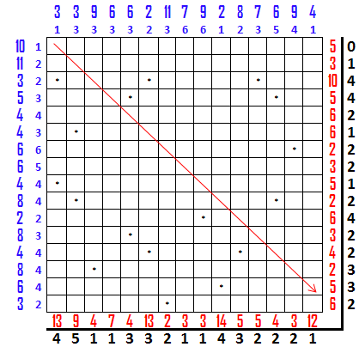

http://www.turkzeka.com

