

WEEK 7:
Pictorial Puzzle
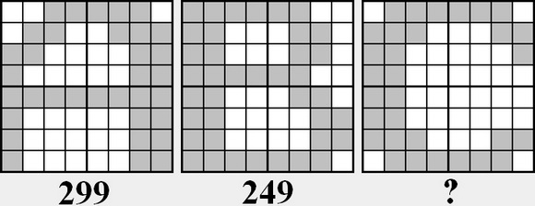
CLUE:
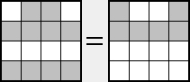

Optimization Puzzle
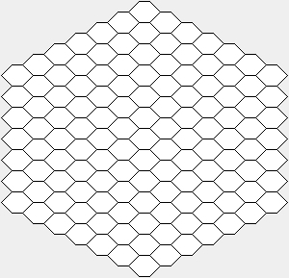
Create the chains in different colors, by painting the honeycombs on the platform above.
Different chains can touch each other, but a chain cannot contact itself.
VALID CHAINS | INVALID CHAINS
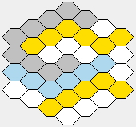 | 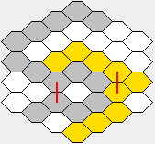
Type the same number into the first and the last honeycombs of the chains you create. This number must be total number of the combs at that chain.
Namely, for instance, type 5 into the first and last honeycombs of the chain which consists of 5 honeycombs.
RULES:
1) The first or the last honeycomb of a chain cannot contact the first or the last honeycomb of an another chain.
2) The first and the last honeycomb of a chain cannot be on the same direction.
There are 3 directions which are extending on the edges (not corners) of a hexagonal honeycomb at the platform above.
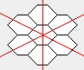
3)There can be more than one chain which have same number of honeycomb. But, the same numbers cannot be on the same directions.
4) The invalid chains and the valid but placed as against the rules, do not invalidate your solution. However, all honeycombs which create these chains is accepted as an empty honeycomb on the score calculating.
CORRECT SOLUTIONS:
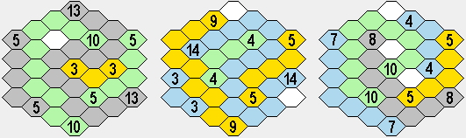

INCORRECT SOLUTIONS:
RULE 1 | RULE 2 | RULE 3
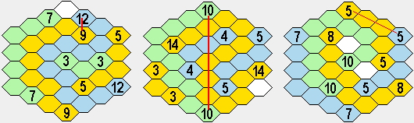
SCORE CALCULATION:
Firstly, multiply number of honeycombs of all the chains which are valid and placed correctly, with each other. Then divide it by the total number of the empty honeycomb. This will be your score.
ATTENTION! All honeycombs of the all invalid and placed incorrectly chains must be accepted as empty honeycombs.
(If there is a invalid placement in a chain, it will be invalid chain)
In case your solution is correct; if you success to leave no empty honeycombs on the platform, multiply your score by 3 and enter it as your answer.
Review sample score calculations, carefully.
SAMPLE SCORE CALCULATIONS:
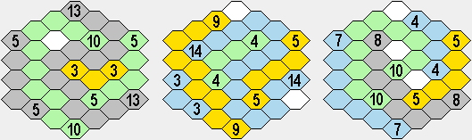
13x5x5x3x10/1 = 9750  SCORE = 9750 | 14x9x4x5x3/2 = 3780  SCORE = 3780 | 7X10X8X5X4/3 = 3733  SCORE = 3733
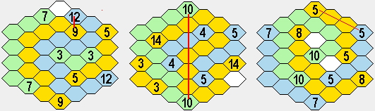
7x3x5/22 = 4.8  SCORE = 4.8 | 14x5x4x3/11 = 76.4  SCORE = 76.4 | 10x8x7/12 = 46.6  SCORE = 46.6

http://www.turkzeka.com

