

WEEK 9:
The Digits with Hearts
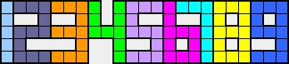
Place the digits above without overlapping, so that every heart is covered and each digit includes exactly that many hearts.
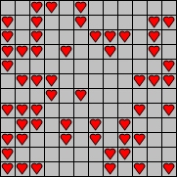
You can turn the digits but can not reflect.
As answer, firstly, enter the number of the blank cells,
then a comma and then the digits you used (in ascending order).
Do NOT use space in your answer!
Example:
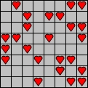 |  | 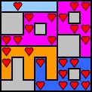
 |  | Answer: 16,13669

