TURKZEKA 2010 – Struggle with numbers (by Erol Kasapoğlu)

Puzzle 1: Scales (8 Points)

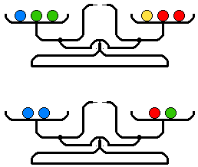 | There are 10 balls with 4 different weights which are 2.8 grams, 2.9 grams, 3 grams, and 3.3 grams.  Distribution of the weight is as follows:  3 of the balls are a grams, 3 are b grams, 3 are c grams and 1 of the balls is d grams.  We have sensitive scales with 2 pans. Scales don’t provide information about weight, they only show whether or not the weights are equal.

We put 3 balls in one pan and 3 in the other pan, and we see the scales are in balance. Even though we try all the possibilities, it is not possible to balance the remaining 4 balls, by putting 2 in each pan.

Find the weight of one ball (the one that weighs d grams).

Puzzle 2: Harvesting the Colours (10 Points)
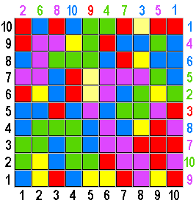  If you remove the colour of any cell in the platform above, all cells which are same colour and adjacent to that cell by the sides (not by the corners) are also removed, and the colours above the empty cells take the places of the removed colours.  Start to remove colours by making use of the clues.  Enter the number that appears at the end as the answer. | Observe the following example carefully.  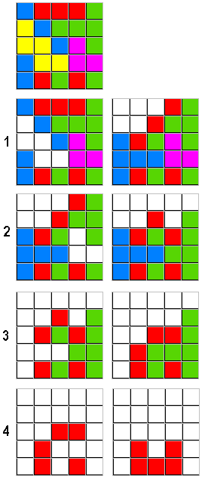

Puzzle 3: KakKuro (12 Points)
Place the numbers from 1 to 9 into the white cells on the platform below. The numbers in gray cells show the total of the numbers placed in white cells that are on the sides without the bold borders of that gray cell.  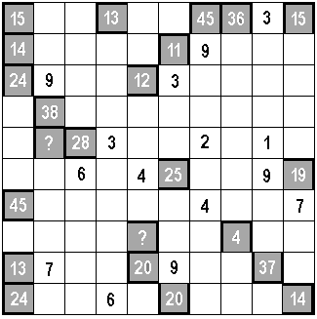 | Sample Incorrect Solution:  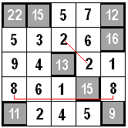

The numbers in the white cells can only be used once in each row and in each column.
You cannot use same number in the adjacent corners of any white cell.

As for the answer, enter the numbers in the two gray cells with the question marks, by separating them with a comma. (First the above number, a comma then the below number) Don’t leave space between numbers.
Sample Answer Format: 23,18

Puzzle 4: Colour Operation (14 Points)
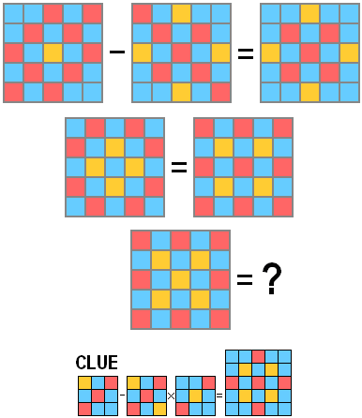
Puzzle 5: Sudoku (16 Points)
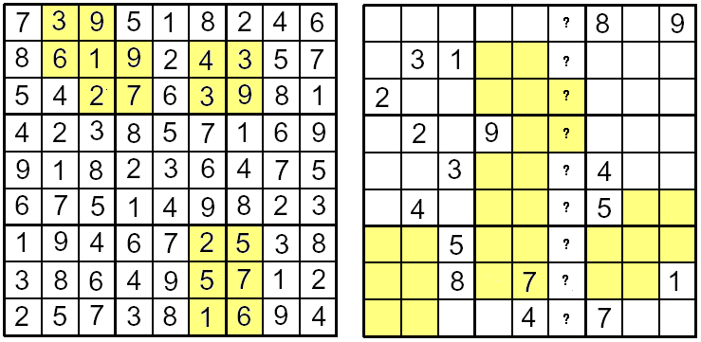

First, try to discover the rule obeyed at the sudoku on the left, then using the same rule, fill the 9x9 grid on the right so that each column, each row, 2 diagonals and each of the nine 3×3 sub-grids separated by bold borders contains all of the digits from 1 to 9.
As for the answer, enter the 9 numbers in the column with question marks, from top to bottom, one by one.
Don’t use comma or leave space between numbers.

Sample Answer Format: 843769251

Puzzle 6: Black Box (20 Points)
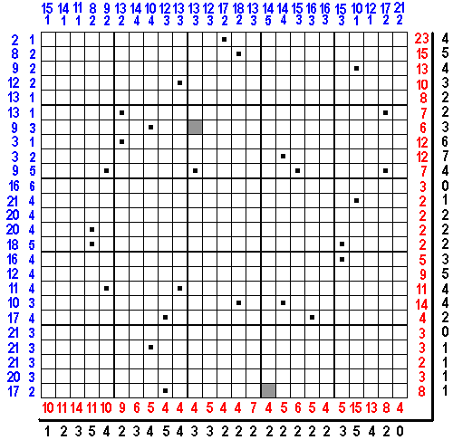

Find out the figure we’ve hidden by blackening some cells on the platform.
The cells with black dot show one of the 4 corners of a square cluster that need be blackened.
That is each cell with a black dot belongs to a different square cluster.
These square clusters can be at least 2x2 sizes. (Or more, 3x3, 4x4, … etc)
These square clusters can be adjacent to each other, but they can never overlap.

The outermost black numbers show how many cluster pieces are on that row or column.
But finding and blackening these square clusters are not enough to form the hidden figure.
Additionally, there are other cells you have to blacken. But none of these cells can form a square cluster.
To find these cells, you will make use of the red and blue numbers. The red numbers show the number of the cells of the longest cell group(s) which is/are blackened in that row or column.

Bigger blue numbers (at the top and on the left) show the total number of cells you have to leave blank (white) in that row or column. Smaller blue numbers show how many group(s) is/are formed with these blank (white) cells in that row or column.

Solve the puzzle above by analyzing the example puzzle and the solution below.
NOTE: 2 cells are already blackened as clues. But, these cells cannot be part of any square cluster.

Your answer must be formed by "0" and "1". Use "0" for white cells, use "1" for black cells.

For your answer, enter the 25 numbers, from top-left to bottom-right (as shown with a red line in the example), one after another, without any space between.

The answer of the example solution should be 001111111

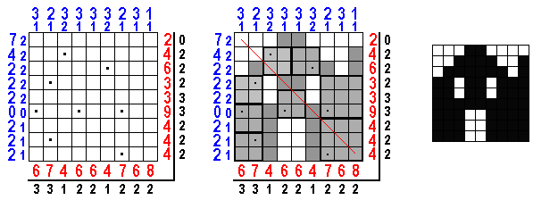

Puzzle 7: Sliding Puzzle Optimization
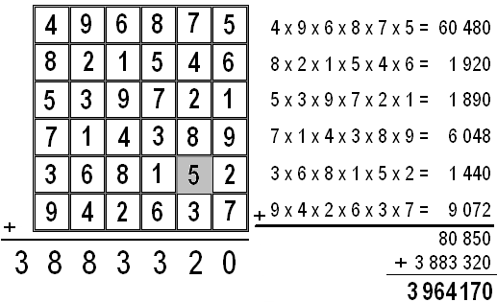
The value of the puzzle above is 3964170.
This value is obtained by adding the total of the all numbers in all rows to the total of the products of all the digits in each row.

Move the numbers by sliding the units of the puzzle up, down, right and left; So that, at least one digit’s place must be changed in each row and in each colum. This means that all numbers in all the rows and columns must be changed.

The numbers in the background of the puzzle that is shown with gray are 1, 2, 3, 4, 5 and 6 for each column, from top to bottom.

SCORE CALCULATION:

First, calculate the new value of the changed puzzle with the method specified above.

To calculate your score, use this formula:
Your Score = New value you get / (|New value you get– 3964170| + Move Count)

Even if the difference of new value you get and the original value of the puzzle is negative, use absolute value (always positive)

Observe the example puzzle, example solution and example score calculation, carefully.

EXAMPLE:
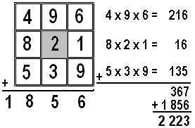

SOLUTION OF THE EXAMPLE:
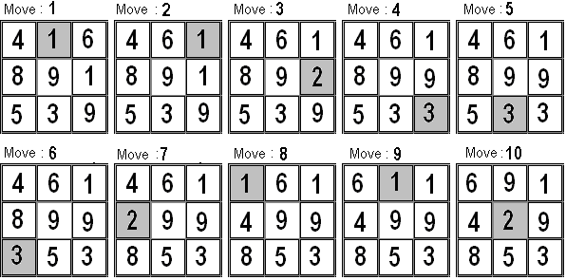

EXAMPLE SCORE CALCULATION:
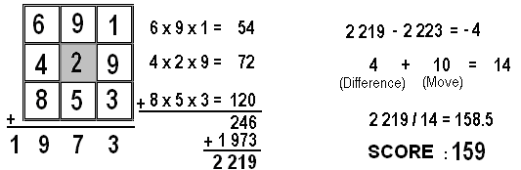

ANSWER FORMAT: First write your score, then put a semi-colon, then by starting from your first move, write the digits you moved one by one and without leaving space between them.

The answer of the example solution: 159;9619358469
POINT: The person with the highest score gets 25 points.
Each person following gets 24, 23, 22, ……………. and 11 points respectively.
Everybody who reaches the score of 1200 gets 10 points.

Puzzle 8: KakKuro Optimization
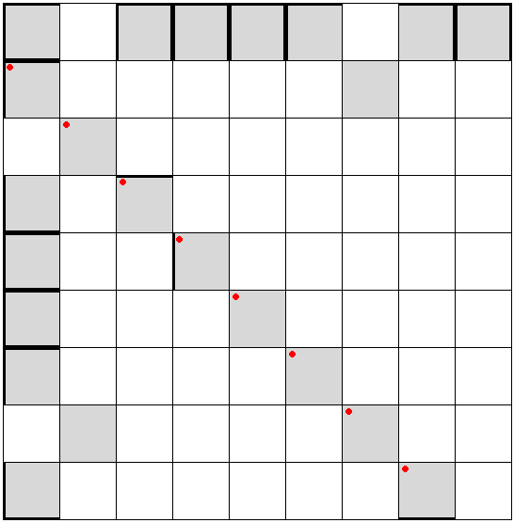
Place numbers between 1 and 9 into the white cells and put numbers between 1 and 44 into the gray cells.
MAIN RULES:
1) The number you put in a gray cell should be the total of numbers that are placed on the sides WITHOUT the bold borders of that gray cell. (Look at the example)
2) Some bold borders are already put in but you can add more bold borders if you need to.
Example Board |  | Example Solution
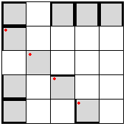 |  | 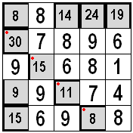

3) You can not cover all 4 sides of a gray cell with bold borders. At least one side of a gray cell should be a regular border and that side has to be adjacent to a white cell.
4) Two gray cells that are on the same row or on the same column and that don’t have any other gray cells in between have to be separated by a bold border.
This means you cannot put the total of the same digits sequence in both.
5) You cannot put a bold border in so that a white cell is totally isolated. That is each number in white cells have to be part of a total in at least one gray cell.
Please examine the examples below.
Against the 3rd rule |  | Against the 4th rule |  | Against the 5th rule
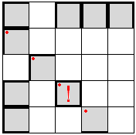 |  | 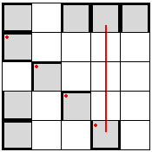 |  | 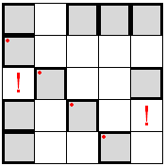
6) If you need to, you can turn some white cells into gray cells yourself. But you cannot use the white cells that would break the 3rd, 4th and 5th rule while doing that. You can not eliminate the gray cells already put in.
White cell you turn into a gray cell may affect your score negatively. About this, observe the score calculation carefully.
THE CELLS YOU CAN TURN INTO GRAY CELLS ACCORDING TO THE EXAMPLE BOARD
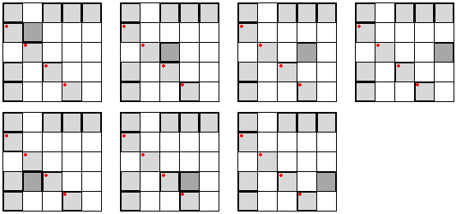
THE CELLS YOU CAN’T TURN INTO GRAY CELLS ACCORDING TO THE EXAMPLE BOARD.
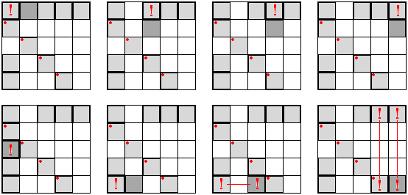
7) The numbers in white cells that are in the same row or in the same column have to be different. Also, the numbers in gray cells that are in the same row or in the same column have to be different. (Please look at the example below.)
INVALID SOLUTION |  | INVALID SOLUTION |  | VALID SOLUTION
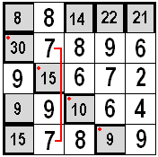 |  | 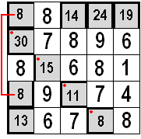 |  | 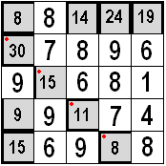
WARNING! Solutions that are against any of the 7 rules will be considered invalid and get 0 points.
THE RULE OF OPTIMIZATION:
For the numbers in the gray cells that are in the same row or in the same column, each digit has to be different. That is, you cannot use 14 and 42 or 8 and 38 in the same row or in the same column, nor can you use 44, 33, 22 or 11 in gray cells. Any digit put in that is against this rule will be considered 1 mistake.
For example if you used 12, 8, 27 and 34 in the same column or same row , this would be considered 1 mistake when calculating your score, or if you used 8, 13, 18 and 33 in the same column or same row, this would be considered 4 mistakes.
CALCULATING YOUR SCORE:
The numbers in the gray cells with red dots will be used for the calculation of the score. If this number is the total of only one series of numbers, its value is the number itself. If it is the total of 2 series of numbers , then its value is double the number itself. If it is the total of 3 series of numbers, then its value is triple the number itself. And if this number is the total of 4 series of numbers from all 4 sides of this cell, then its value is the square of the number itself.
First of all, multiply the values of the numbers in gray cells with red dots and find your score.
Then divide this score into the numbers of mistake you have (considering also that each gray cell you added is 1 mistake) and reveal your real score.
If you haven’t broken the rule of optimization in the whole game, add 10% to your score.

Please observe the score calculation examples below:
EXAMPLES OF SCORE CALCULATION
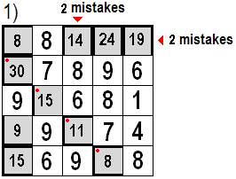 |  | 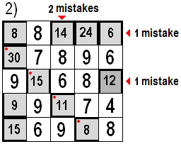
Main Score = 30 x 45 x 11 x 8 = 118800  Total number of mistakes = 4  SCORE = 118800 / 4 = 29700 |  | Main Score = 30 x 30 x 11 x 8 = 79200  Total number of mistakes = 4 + 1 gray cell = 5  SCORE = 79200 / 5 = 15840
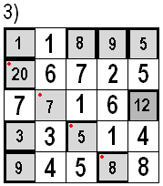 |  | 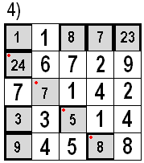
Main Score = 20 x 49 x 10 x 8 = 78400  Total number of mistakes = 0 + 1 gray cell = 1  SCORE = 78400 / 1 = 78400 x 1.1 = 86240 |  | Main Score = 24 x 49 x 10 x 8 = 94080  Total number of mistakes = 0  SCORE = 94080 x 1.1 = 103488
ANSWER FORMAT: First write your score, put a semi-colon , then starting from the upper left corner and going row by row, write all numbers separated by a comma. Put the numbers in the gray cells YOU added in parenthesis.
Here are the answers for the examples 3rd and 4th from above:
86240:1,1,8,9,5,20,6,7,2,5,7,7,1,6,(12),3,3,5,1,4,9,4,5,8,8
103488:1,1,8,7,23,24,6,7,2,9,7,7,1,4,2,3,3,5,1,4,9,4,5,8,8
POINT: The person with the highest score gets 25 points.
Each person following gets 24, 23, 22, ……………. and 11 points respectively.
Everybody who reaches the score of 100 billion gets 10 points.

